**Machine Learning**



**Medical Super Image Resolution using GAN**

**Group Id- GAN-2**

**Submitted by-2022UCS1504,07,15013,1522,1564,1567**

**Submitted to-Dr. Poonam Rani**

**Abstract**

GANs refer to unsupervised learning models, which are employed for generating credible and genuine data sets in large volumes. These they do through an adversarial process, where a generator generates synthetic datasets while a discriminator distinguishes between real and synthetic datasets. The goal is to reduce the Generator’s error and at the same time increase the Discriminator’s ability to differentiate between the two with the end result of enhancing the Generator’s capacity to create more realistic outputs. If the model is sufficiently trained, then in the real world it can be used for working purposes. For instance, the creation of high-quality MRI images entails certain dangers related to the increased expense of time and possible irradiation danger. To tackle this challenge, GAN-based super-resolution techniques can reconstruct high-quality images that can act as reference images in increased resolution without exposing the patients to radiation.

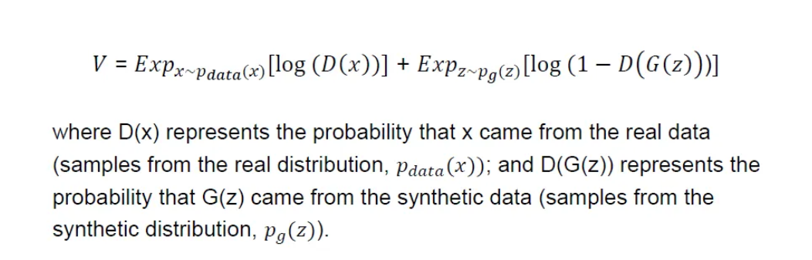

**Introduction**

MRI, CT, and ultrasound are useful clinical and research tools for visualizing internal structures and quantifying them when necessary. However, the spatial and contrast resolutions of these images may be poor due to technical constraints, patient conditions, and shorter scan times for 3D reconstructions. Other methods involve reduced field of view (FOV) and k-space sampling, PI, and CS for faster MRI that causes aliasing artifacts. For MRI reconstruction, deep learning solutions have appeared using different strategies that take into consideration the correspondence of high-quality ground truth and under-sampled images. Even though single image SR has generated favorable results in natural scenes using perceptual loss and GANs for reconstruction its logistics to medical images are still a problem especially due to blurry structures and lesser amount of data. This work proposes a new model called SOUP-GAN (Super-resolution Optimized Using a Perceptual-tuned GAN) that will enhance the thin-slice MR images’ resolution from the thicker clinical images. Major achievements include designing an SR architecture that effectively captures scale attention for arbitrary sampling factors chosen by the user, introducing a 2D perceptual loss model to 3D medical images, and also proposing criteria that can be used for data preprocessing for different acquisition protocols.

Our model is designed to be generic and applicable to various types of images such as T2-weighted MRI and CT using which one can predict that the SR interpolations can be effectively done in medical images.

**Background of Medical Image Super-Resolution**

MRI and CT scans, ultrasound, and X-rays all refer to medical imaging techniques. Tomography (CT) scans and X-rays are indispensable for modern diagnostic procedures with the help of which doctors produce non-invasive pictures of the internal structures of the human body. These imaging tools are important for diagnosing, various illnesses, formulating, treatment regimens, and overseeing procedures. Operations, and the progress of diseases in the body. Depth in these medical images is a critical aspect that determines whether the systems are able to capture minor details. For example, small tumors, slight cracks in bones or ligaments, or even slight changes in the structure of the tissues. High-resolution images give more precise information and it is very important in order to early detect the disease. Effective treatment planning. However low resolution does not possess sufficient resolution necessary for identification. Which can lead to a lack of diagnosis of certain diseases, misunderstanding of certain diseases, and delayed treatment. The main drawbacks that interfere with the reception of low resolution are the deficiencies of imaging. Patient support, patient transfer during scans, and concern to reduce radiation effects in methods of imaging such as computerized tomography scans and radiography. These can lead to blurring, noise, and reduction of contrast, plus many other problems. At the level of the images, it has an impact on the respective clarity in terms of medical diagnostics and assessment.

Consequently, improving the enhancement of these images by application of high-end techniques such as super-resolution algorithms has emerged as an area of focus in medical images in order to increase diagnostic precision and patient outcomes.

**Importance of Super Resolution**

In medical imaging resolutions are important so that the physician can accurately diagnose the patient and determine the best course of treatment. Reconstruction of high-definition images from low-definition images is the focus of super-resolution methods since it is an efficient way to enhance image quality without compromising scan time or exposure to radiation.

**Improved Diagnostic Accuracy**

When the resolution of the image is poor it becomes hard to notice tiny features which are so essential for diagnosis. Such details can be better seen by clinicians using super-resolved images.

**Cost Efficiency and Patient Safety**

In general, SR techniques can allow healthcare providers to gain the required diagnostic image quality with the same equipment or even lower price as compared with prior imaging that may have required multiple acquisitions, which in turn, would expose the patient to dangerous radiation levels.

**Real-time Applications**

Many operations like robotic surgeries and diagnostics in emergencies depend on the data from image processing in real time. Such real-time generated high-resolution images using the GANs can help in enhancing such results.

**Problem Statement**

When applied to medical imaging, there are several issues that GANs solve for:

One major challenge is that most of the conventional MRI methods acquire images with low spatial resolution especially where shorter scans are required. From the low-resolution images, GANs can produce highly detailed resolution images making the graphic much clearer. However, several studies have shown that using conventional loss functions such as mean squared error (MSE) smoothes out textures on the generated images. According to the experimental results, GANs especially in the use of perceptual loss make it possible to obtain apparently flawless images close to high-quality ground truth. They also reduce aliasing artifacts resulting from the under-sampling of the k-space by learning to generate higher accurate images from under-sampled data.

In addition, since traditional models are constrained to 2D image inputs, they inspired GANs to change the format of the perceptual loss to better suit 3D work in imaging volumetric data. They also improve training processes through the production other more images of similar quality to augment those limited data sets that may not be sufficient for training deep learning training models.

Last of all, GANs are versatile and can be adapted to medical T2-weighted MRI and CT images, whereby high-resolution image generation can be attained irrespective of the implementation of different image types. If resolved, these problems contribute to enhancing the usefulness of medical images for clinical diagnosis and research by increasing the capabilities of GANs.

**Objectives**

1) For developing and proposing a GAN-based Super-Resolution model which we strongly believe can help synthesize realistic medical images from multiple modalities.

2)To compare the effect of the model in improving diagnostic accuracy as the high-resolution images preserve minor physiological structures.

3) To assess the degree of artifact reduction incorporated in constructing GAN for its practicability in healthcare.

4) For the purpose of comparing the computational complexity of the proposed model with other Super-Resolution techniques.

5) Besides, we will show the comparison result of the proposed model to evaluate PSNR and SSIM values and the result from the medical field perspective.

**Evaluation Metrics**

**Perceptual Loss(Visual Information Fidelity)**

It is employed to calculate the similarities between the extracted features from the input image, allowing us to assess the similarities between the output and the target. We compute both the content loss and the Gram loss, which are then added to the final loss.





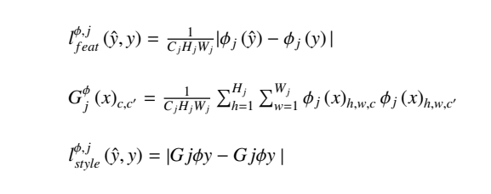

**Adversarial Loss**

Adversarial loss makes the generator function produce new images that can be classified by the discriminator (DθD) as real, while the discriminator should be able to reject them.

MAE loss is combined with Perceptual Loss from a pre-trained VGG19 to decrease the image smoothness and Gram Loss to avoid the decrease in image sharpness. Compound with the L1 loss which computes pixel-wise differences, a weighted loss from the VGG19 layers is also utilized.

At the end of 30 epochs, the combined losses enhanced the realism as well as the texture of the generated images and a standard discriminator loss to distinguish real images from simulated ones.

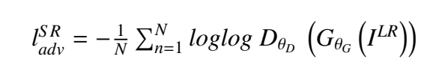

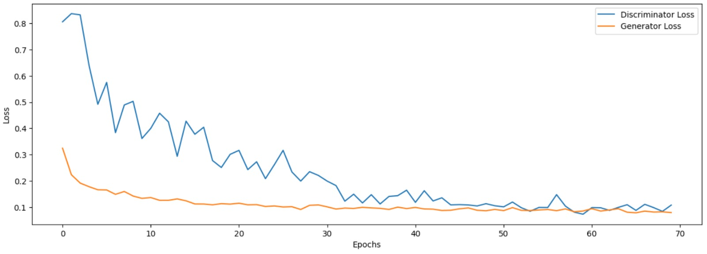

**Mean Absolute Error(Peak Signal to Noise Ratio)**

It aids in determining the mean value of absolute deviations, that is, the difference as to amount. In this regard, it would mean the difference between the desired pixel and the expected pixel in the given situation. Since it is an absolute measure it doesn’t take direction and therefore gets rid of the direction factor which could have made the bias higher. It resolves one more issue which is the disappearance of lower values that could have been achievable in mean squared error. For the sake of notation, we set N to be the number of samples drawn at a time, with yi equating to the target image, and ˆyi being its generation from the model. We write the MAE as:

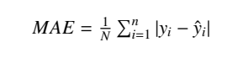

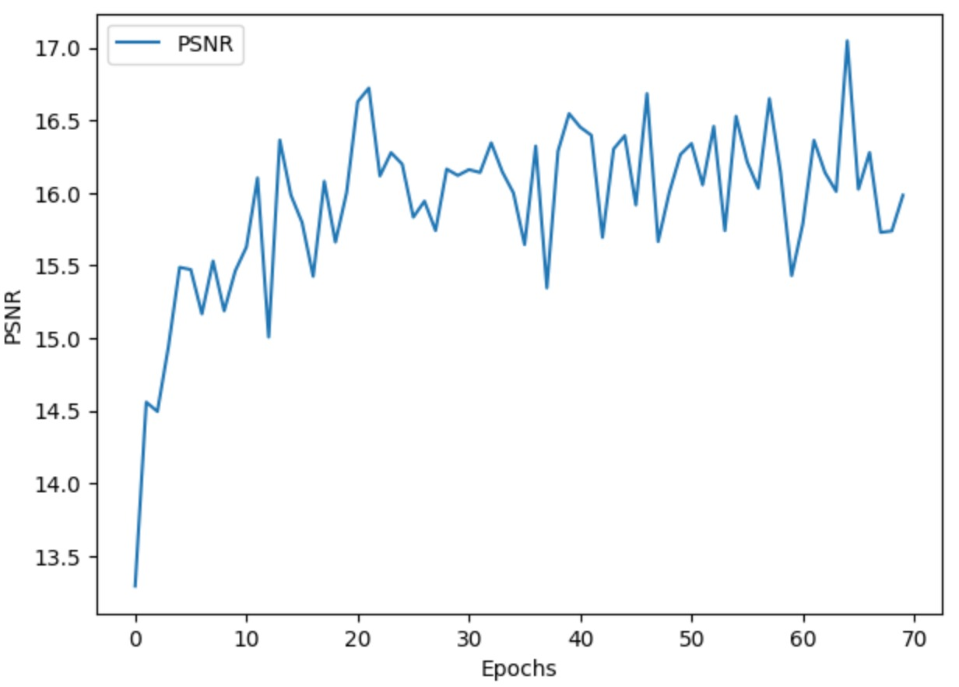

**Learning Rate Scheduler**

In the first two stages, the one-cycle scheduler was used, along with a moderately high learning rate, weight decay for regularization, and momentum-based smoothing using Adam's betas (0.9, 0.99).

Stage 2 introduced a discriminative learning rate strategy, adapting the learning rate across layers, while keeping weight decay and momentum. In the final stage, a low learning rate (0.0001) was used to fine-tune the generator and discriminator, with no momentum (beta1 = 0) for more precise updates.

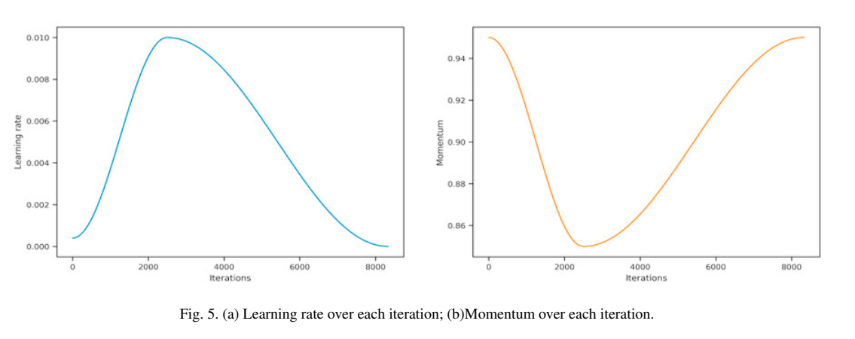

**Baseline Models**

**1. Basic GAN Model:**

* **Structure:** generator and discriminator which exist in an opposing relationship.
* **Generator:** Learns how to generate similar data (for instance images) to the real data in the given set.
* **Discriminator:** Attempts to differentiate between the two domains of real and fake data.
* **Training:** The generator, in turn, improves its capacity to fool the discriminator and vice versa, the discriminator improves the capacity to categorically distinguish real data from fake ones. This process of generating and discriminating data goes on until the generator generates alternate data which is real.
* **Limitations:** Some drawbacks of the basic GANs are unstable training situations, which can result in some problems, such as mode collapse, where the generator generates almost no variation in the generated images**.**

**2. GAN + Inception Module:**

* **Structure:** In this model, the Inception Module is embedded within the GAN for the construction of generating multi-scale features**.**
* **Inception Module:** It applies only one filter and runs this in parallel with the others of various sizes like 1x1, 3x3, 5x5, etc. so that the network can be able to assist in detecting features of different scales within the data.
* **Usage: improves the resolution of low-**quality medical images by incorporating the Inception modules to take better multi-scale representations. This model is particularly suited for medical imaging tasks where it’s important to capture high-frequency details across scales, for example, tumor or lesion detections, etc.
* **Benefit:** By using inception modules, the model can extend the depth of features that can be extracted from the data and, therefore, produce an improved and focal image.

**3. GAN + Residual Blocks:**

* **Structure:** This type of GAN has integrated the residual blocks into the architecture of the GAN in its own architecture**.** Residual blocks are made of layers where an input undergoes a series of transformations, however, there is a connection going around the transformations and adds the input to the layers’ output.
* **Usage**: improve the quality and performance of synthesized medical images mainly in applications such as SR, de-noising, and reconstruction.
* **Benefit:** It increases the flow of gradients in backpropagation; this eradicates the vanishing of gradient problems common in deep networks. This was done in order to enable the GAN to train faster and provide better quality images as well as train the GAN in a complex manner to allow for smoother training during the next phase.

**4. SRGAN (Super-Resolution GAN)**

* **Architecture**: A GAN architecture was proposed for SR tasks, the aim of which was to obtain high-resolution images using low-resolution images as inputs.
* **Usage**: Characteristic use is in image enlargement applications, ranging from improvement of the resolution of medical images, satellite images, or even informal photographs.
* **Strength**: An ideal platform of super-resolution to be used as a benchmark for other methods as it scales the images with high amplification rates and higher resolution.

**5. ESRGAN (Enhanced Super-Resolution GAN):**

* **Structure:** Compared with SRGAN, ESRGAN introduces a new structure, called Residual-in-Residual Dense Block (RRDB), and the relativistic GAN (RaGAN) is used to make the generator and discriminator more competitive.
* **Use Case**: Imaging super-resolution tasks where accurate and high-resolution images are needed.
* **Advantages**: It offers better and more realistic image super-resolution hence making it the best tool in cases of super-resolution.

**GAN Training**

1. **Overview of GAN Training**:

The training of a GAN consists of two neural networks: Two primary components of the model: one is generative and the other is discriminative and the two work antagonistically. The generator has the ability to generate very clear images using low-resolution medical images, while the discriminator’s main job is to be able to tell the difference between the original real images from the medical field and those images that have been generated by the generator. The generator must also be able to generate image data which the discriminator will be unable to distinguish from the original data which also increases with time.

**2. Key Steps in GAN Training**

**a. Data Preprocessing:**

* **Input Data**: It starts with low-resolution images based on medical images as inputs and the images with higher resolution as the references. These images are normalized with some having been reconstructed and the total set is expanded to achieve better model performance as well as model versatility.
* **Image Augmentation**: Rotations, scalings, and flips are used on the data used in the dataset which involves variability and therefore lacks overfitting of the model because it is trained on different data facets.

#### **b. Adversarial Training:**

* **Generator Objective:** The generator operates to present high-quality images as most medical images in real life. Its objective is to reduce the divergence between the generated and real high-definition images to enhance the quality of its performance.
* **Discriminator Objective**: Discriminator should be able to provide the correct output for fake images as generated, and the correct output for genuine images as real.

#### **c. Loss Functions:**

* **Adversarial Loss:** The generator must try to deceive the discriminator and that is where the adversarial loss function will help. It aids the generator in its effort to generate images that are very difficult for the discriminator to razor off as fake.
* **Perceptual Loss:** This loss measures the difference between the high-level features of the generated and the real image with pre-trained models to make sure the generated image looks like the real one. This is particularly useful in order to retain the super fine details that are normally associated with medical images.
* **Content Loss:** The pixel-wise difference between the life-generated high-resolution image and the ground truth, normally calculated through L1 or L2 loss, makes sure that the generated image is nearly like the actual high-resolution one.
* **Total Variation Loss:** This minimizes noise in the generated images and increases the chances of continuity, which is pleasing to the eyes and has no common faults.

#### **d. Optimization:**

* They train the network in an alternate fashion – the generator and then the discriminator. The generator tries to reduce its loss while at the same the discriminator tries to enhance its score in telling fake images from the real ones. Adam optimizer is used to update both networks to perform the gradient updates because of its effective method.

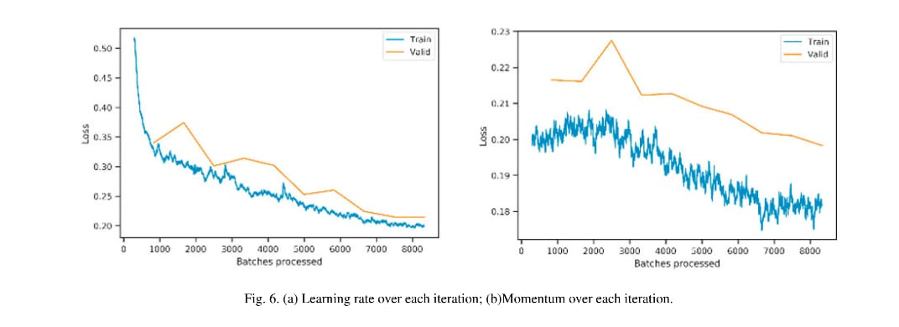

#### 

#### **e. Training Iterations:**

* In each iteration of the generator, a low-resolution image is used as an input, and a high-resolution image is produced. The discriminator assesses both the generated and genuine images and then indicates to the generator the changes that should be made. It continues until the generator can synthesize images that are functionally similar to the actual high-definition images.

### **3. Evaluation Metrics:**

* **PSNR (Peak Signal-to-Noise Ratio)** and **SSIM (Structural Similarity Index)** are used to quantitatively measure the quality of generated images. Higher values of PSNR and SSIM indicate that the generated images are of higher quality and closer to the real high-resolution images.
* **Perceptual Evaluation:** However, to quantify the quality of images, a group of expert radiologists or other medical practitioners may rate the generated images for their fitness for purpose in diagnosis and to evaluate if the generated images are sufficiently realistic for practice.

**Implementation of GAN-Based Image Resolution Enhancement**

The project was aimed at enhancing the resolution of medical images including MRI scans and CT scans through models. The training set contained LR and HR images which are helpful for training a model for image quality improvement.

**1. Preprocessing of the Dataset**

**Input Data**: The inputs, represented as low-quality images, were provided alongside high-quality images as reference outputs, or ground truth, for the models.

**Normalization**: To enhance stability in training, pixel intensity of both low and high-resolution images was normalized to the range [0, 1].

**Data Augmentation**: In an effort to expand the variation of the training set and also to make the data more robust, several image enhancement methods were employed.

**Rotation**: The specimen was rotated around the large axis at random angles of up to 45 degrees to represent various directions

**Flipping**: Greater variation was induced randomly by applying flips in both the horizontal and the vertical direction.

**Scaling**: Figures were distorted and enlarged or reduced in size apparently at random so as to depict different degrees of magnification.

**Shifting**: Some of the changes were random in nature to mimic small positional adjustments.

**2. Model Training Process**

**GAN Architectures**: Different GAN models were employed in order to perform the task of image super-resolution and image resolution enhancement.

**Basic GAN**: Mainly applied to enhancement tasks; a popular example is to enlarge low-quality inputs into high-quality images.

**Super-Resolution GAN (SRGAN)**: This architecture was developed primarily for use in cases of super-resolution images, where the objective of the generator is to enhance the images’ resolution.

**Enhanced Super-Resolution GAN (ESRGAN)**: An improved version, which includes the addition of residual-in-residual dense blocks (RRDB) for better, perceptive quality and details.

**Training Configuration**:

**Loss Functions**: These models used multiple losses including Adversarial loss to make the generated images real, Perceptual loss with a pre-train VGG network to capture image features, and content loss (L1 loss) to retain similarity between the generated images and target images.

**Learning Rate Strategy**: To begin training from the most general setting of the parameter space, a one-cycle learning rate scheduler was used. The weights of both generator and discriminator networks were modified using the Adam optimizer.

**Training Cycles**: The models were trained over 100 ITERATIONS with the BATCH SIZE equal to 16. The problem of gradual degradation in model performance was avoided, through periodic cross-validation of the training process, with the help of validation metrics such as PSNR and SSIM.

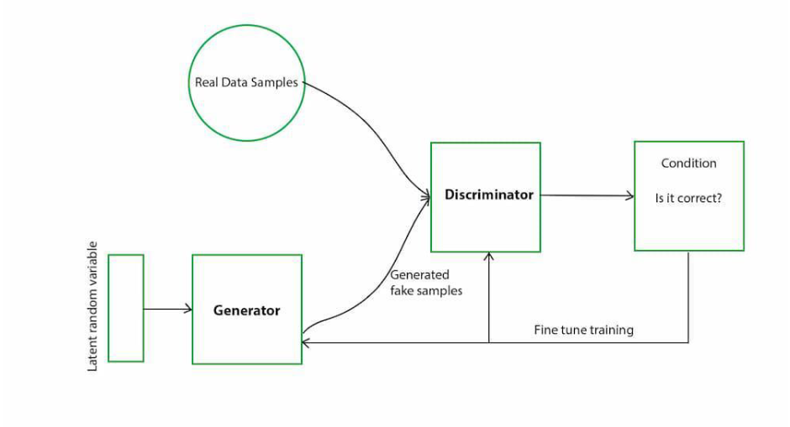

**Architecture**

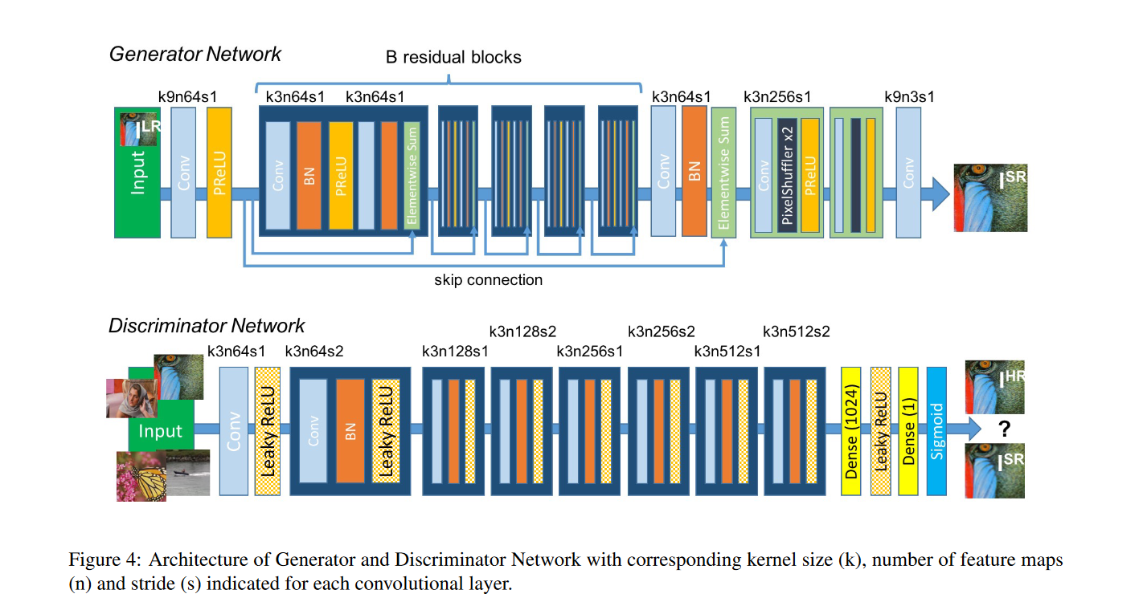

**Generator Architecture:**

The generator is initiated by a dense layer that transforms the input data into a suitable format.

A few Conv2DTranspose layers are used, which helps to increase the resolution of the images in the different stages.

In this work, batch normalization is applied following each of the transposed convolutions in order to normalize the weights and thus make the training process more stable and faster.

Non-linear transformations are achieved with ReLU between the layers but the Tanh activation function is used in the output layer for construction of the final high-resolution image.

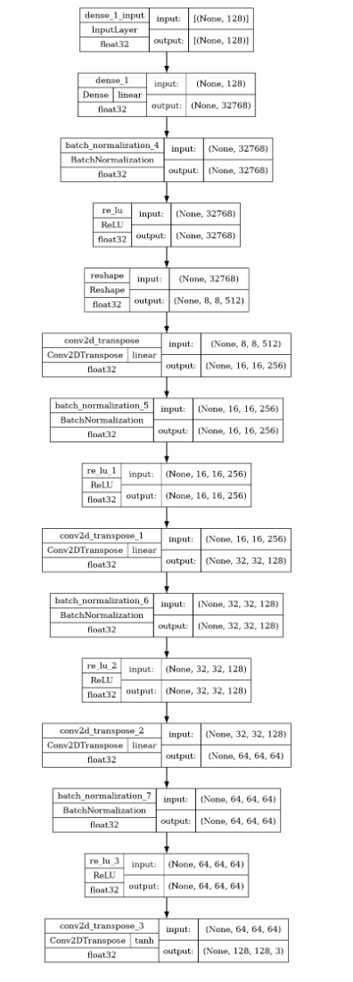

**Discriminator Architecture:**

The discriminator involves Conv2D layers in sequence, followed by LeakyReLU activation.

To categorize the real high-definition images and the fake high-definition synthetic images.

For the purpose of training regularization, batch normalization is added immediately after each convolutional layer.

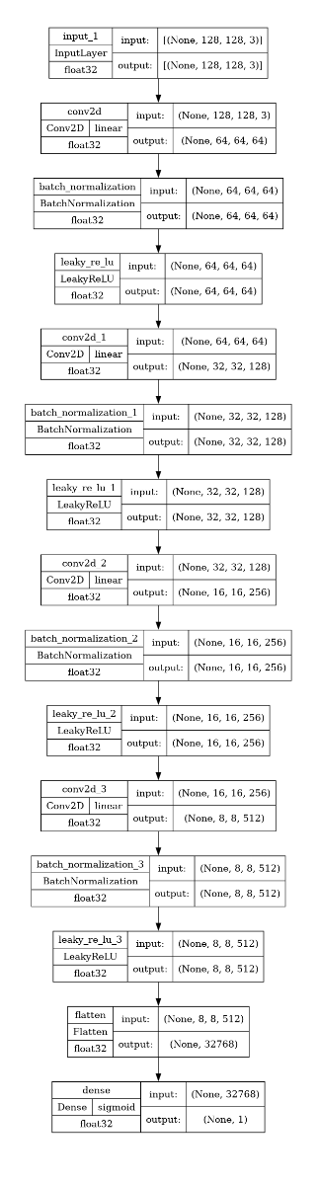

**Literature Review**

| **S.NO** | **TITLE** | **METHODOLOGY** | **MODEL** | **ACCURACY**  **RESULT** | **LIMITATIONS** |
| --- | --- | --- | --- | --- | --- |
| **1** | Image  Super-Resolution  using Generative  Adversarial Networks  with EfficientNetV2  <https://thesai.org/Publ>  actions[/ViewPaper?V](https://thesai.org/Publ)  [olume=14&Issue=2&](https://thesai.org/Publ)  [Code=IJACSA&Serial](https://thesai.org/Publ)  [No=100](https://thesai.org/Publ) | It revolves around  an advanced  Generative  Adversarial Network  (GAN) architecture  called ISRGAN  (Image  Super-Resolution  GAN), where the  EfficientNetV2  model is integrated  into the  discriminator  network. | GAN  architecture  and  EfficientNet  V2 | It achieves  results, including  a Peak  Signal-to-Noise  Ratio (PSNR) of  45.57 and a  Structural  Similarity Index  Measure (SSIM)  of 0.9997. The  model also  reports minimal  Mean Square  Error (MSE) and  Mean Absolute  Error (MAE). | 1. Overfitting in Small  Medical Datasets.  2. EfficientNetV2  combined with GANs  increases the model's  complexity, which  requires significant  computational  resources.  3. Models like  EfficientNetV2 in  combination with  GANs may struggle to  generalize across  various medical  imaging modalities  (e.g., ultrasound vs  MRI). |
| **2** | A new generative  adversarial network  for medical images  super-resolution  <https://www.nature.co>  [m/articles/s41598-02](https://www.nature.co)  [2-13658-4](https://www.nature.co) | It focuses on a  multi-path  architecture for  shallow feature  extraction,  ResNet34 for deep  feature extraction  and upscaling, and  a mini-CNN with  residual connections  for further feature  extraction.  Progressive  upscaling is used to  improve image  quality. | ResNet34  and GANs | The model  demonstrates  superior  accuracy on  multiple medical  datasets,  including retinal,  MRI,  dermoscopy,  and ultrasound  images | 1. While GANs  enhance image  the resolution, they might  not accurately restore  small but crucial  details such as fine  textures which are  critical for medical  diagnosis.  2. GAN models,  especially those  tailored for  super-resolution tasks,  can be computationally  expensive |
| **3** | Single MR Image  Super-Resolution  using Generative  Adversarial Network  <https://www.research>  [gate.net/publication/3](https://www.research)  [62089248_Single_M](https://www.research)  [R_Image_Super-Res](https://www.research)  [olution_using_Gener](https://www.research)  [ative_Adversarial_Ne](https://www.research)  work | It focuses on a  modified version of  the Real-Enhanced  Super Resolution  Generative  Adversarial Network  (Real-ESRGAN).  The study  incorporates  quantitative  validation using  several metrics such  as SSIM (Structural  Similarity Index  Measure), NRMSE  (Normalized Root  Mean Square Error),  MAE (Mean  Absolute Error), and  VIF (Visual  Information Fidelity) | Real-  ESRGAN  architecture | it reports the  effectiveness of  the modified  Real-ESRGAN  model through  improvements in  image quality,  validated by the  metrics. | 1. The model might not  generalize well across  different medical  imaging modalities.  2. GANs may  introduce unnatural  artifacts or lose crucially  medical details,  compromising  diagnostic accuracy.  3. GANs, especially for  MRI images, demand  substantial  computational power  due to complex  architectures |
| **4** | 2D MRI Super  Resolution Using  Generative  Adversarial Network  <https://papers.ssrn.co>  [m/sol3/papers.cfm?a](https://papers.ssrn.co)  [bstract_id=4291804](https://papers.ssrn.co) | It focuses on Super  Resolution (SR),  where low-resolution  MRI images are  enhanced to higher  resolutions. | GANs | t evaluates the  performance of  the model-based  on common  metrics for  image  super-resolution  tasks, such as Peak  Signal-to-Noise  Ratio (PSNR)  and Structural  Similarity Index  (SSIM). | 1. GAN-based models  can introduce artificial  patterns (artifacts) in  the reconstructed  images that were not  present in the original  images.  2. GANs may be sensitive to noisy or  corrupted input  images, which can  degrade the quality of  the super-resolved  output. |
| **5** | SOUP-GAN:  Super-Resolution  MRI Using  Generative  Adversarial Networks  <https://www.mdpi.com>  [/2379-139X/8/2/73](https://www.mdpi.com) | It focuses on  enhancing the  resolution of MRI  images, particularly  in the Z-plane, by a  3D super-resolution  approach based on  a GAN architecture,  which is optimized  using perceptual  loss. | Model  combines a  GAN  framework  with a  perceptual  loss  function. | SOUP-GAN  outperforms  traditional  super-resolution  methods.  Significant  improvement in  metrics were  shown like  PSNR, SSIM,  and RMSE,  indicating better  image quality  and higher  fidelity in  super-resolved  MRI images. | 1. SOUP-GAN, rely  heavily on large  datasets for training.  2. GANs require  significant  computational power  for training and  inference when  applied to  high-dimensional  medical images like  MRI.  3. GAN-based models  may not always handle  noise present in  low-resolution images  effectively, leading to  unrealistic or  inaccurate  super-resolved  images |
| **6** | Advancing Medical  Imaging Through  Generative  Adversarial Networks  <https://link.springer.co>  [m/article/10.1007/s12](https://link.springer.co)  [559-024-10291-3](https://link.springer.co) | It focuses on  Self-Attention GANs  (SAGAN),  Conditional GANs,  and Progressive  Growing GANs  (PGGAN) | GANs | It focuses on a  comprehensive  review of the  applications and  potential  advancements  of GANs in  medical imaging. | 1. The generator may  produce a limited  variety of images,  affecting image  diversity and quality.  2. GANs are often  difficult to train due to  the adversarial nature  between the generator  and discriminator |

**Comparative Results**

Specifically, it can be mentioned that modern deep learning methods, including GANs and specific types of encoders, known as autoencoders, can significantly enhance the quality of images used in diagnostics. This paper compares the two technologies and shows how the strengths, the outcomes, and the limitations of each underline the versatility of the two within the healthcare field. A detailed analysis of the overall performance of each technology in the critical areas is provided below.

**Digital Image Processing**

**Capabilities**

**GANs**

As explained earlier, GANs are intended to produce realistic fake images that resemble clinical images of the human body. GANs are also effective in both enhancing image resolution and dealing with missing values as well as rare situations that are hardly captured within clinical datasets.

**Performance**

**GANs**

It was ascertained from the literature that, through varied and an augmented quantity of training images, GAN-generated images make the diagnostic algorithms more accurate. For instance, GANs have produced convincing fake MRI images that have promoted improvement in accuracy when diagnosing diseases such as brain tumors.

**Data Augmentation & Diversity**

The role of data augmentation is to significantly enhance the model's performance and robustness. In medical imaging, super-resolution is a method of enhancing the images to their high resolution by reconstructing them from low-resolution images that are used where such detail is critically needed for the correct identification of the problem.

In complaints diagnosis, amending, or even viewing high resolution is expensive or restricted by data permissions in healthcare. Therefore, data augmentation is done. It artificially expands the training data by applying transformations such as:

* Rotations, flips, scaling, and shifts: It is desirable to enlighten different directions of medical images.
* Noise injection: One of the contributions is that it can assist the model in being more resistant to real-world noisy data.
* Intensity scaling: This has proven useful in MRI for which variations in intensity are often encountered.
* Elastic deformation: It is in medical images (CT or MRI). Where tissue distortion is likely.
* Image cropping and resizing: It is utilized to stimulate the model with different resolutions and spatial environments.

This first research question aimed at establishing the significance of data augmentation in GANs was answered in the following manner;

* Augmentation strategies guarantee that there is a large input data set hence, GAN models for learning the mapping between low-resolution and high-resolution images are improved.
* They assist GAN models in catering to different real image challenges in the healthcare domain.
* With respect to the type of images I input to the GAN model, the model becomes less sensitive to training images hence minimizing overfitting.

**Challenges:**

* **Long training Time:**

Supervised learning of GANs, in particular for high-resolution medical images, remains a computationally intensive and time-consuming process. This is made even more challenging by the fact that the network architecture is complex with inception modules joined by residual blocks.

* **Model Collapse:**

Mode collapse can be a problem, particularly in medical imaging applications because it will cause a significant restriction of the variety of generated outputs. This is undesirable because medical images need to have high variability to capture all the permutations of anatomical and pathological variations of real-life clinics.

* **Leaving the Generator and Discriminator of similar strength:**

During the training of the GAN, there is a delicate balance between the generator and the discriminator; once one gains the upper hand the process is disrupted. In a medical imaging context, the need to balance rate and quality is critical in generating good-quality images.

* **Small Sample Size of the Dataset and Different Variety of Options:**

A majority of accessible medical imaging datasets are limited in size and sample diversification. This limitation makes the model potentially overfitting, thus its performance lowers when it faces new and unseen medical data which is very important for a diagnostic system.

* **Real and Synthetic Images Discrimination Problem:**

As the generator becomes better at generating realistic images, then the discriminative function finds it more challenging it differentiate between synthetic images and the real ones. This problem is even more crucial in medical imaging because even small errors in creating synthesized images may affect clinical readings.

**Ethical & Practical Considerations**  
**GANs**: While GANs offer substantial benefits, the generation of synthetic data raises ethical questions around data authenticity and the risk of bias in AI models, particularly if the synthetic images do not fully represent clinical realities.

**Encoders**: The primary ethical concern with encoders revolves around the accuracy of the reconstructed images. Excessive denoising or reconstruction could potentially obscure critical clinical details, affecting diagnostic decisions.

**References**

# Super-Resolution using GANs for Medical Imaging-<https://doi.org/10.1016/j.procs.2020.06.005>

# SOUP-GAN: Super-Resolution MRI Using Generative Adversarial Networks- <https://www.mdpi.com/2379-139X/8/2/73>

* Photo-Realistic Single Image Super-Resolution Using a Generative Adversarial Network- <https://ieeexplore.ieee.org/document/8099502>
* Research on Image Super‐Resolution Using Attention Mechanisms based on Super‐Resolution Generative Adversarial Network[Zhouli Wu] <https://drpress.org/ojs/index.php/fcis/article/view/13142>

# Csrgan: Medical Image Super-Resolution Using A Generative Adversarial Network- <https://ieeexplore.ieee.org/document/9153436>

* Single MR Image Super-Resolution using Generative Adversarial Network- <https://www.researchgate.net/publication/362089248_Single_MR_Image_Super-Resolution_using_Generative_Adversarial_Network>
* 2D MRI Super Resolution Using Generative Adversarial Network- <https://papers.ssrn.com/sol3/papers.cfm?abstract_id=4291804>
* Medical Image Super-Resolution Using Improved Generative Adversarial Networks XINYANG BING, WENWU ZHANG, LIYING ZHENG, AND YANBO ZHANG
* [The super-resolution reconstruction in diffusion-weighted imaging of preoperative rectal MR using generative adversarial network (GAN): Image quality and T-stage assessment](https://www.sciencedirect.com/science/article/pii/S0009926024005026)-<https://www.sciencedirect.com/science/article/abs/pii/S0009926024005026>
* 3D Auto-context-based Locality Adaptive Multi-modality GANs for PET Synthesis:<https://link.springer.com/article/10.1007/s12559-024-10291-3>

**Code**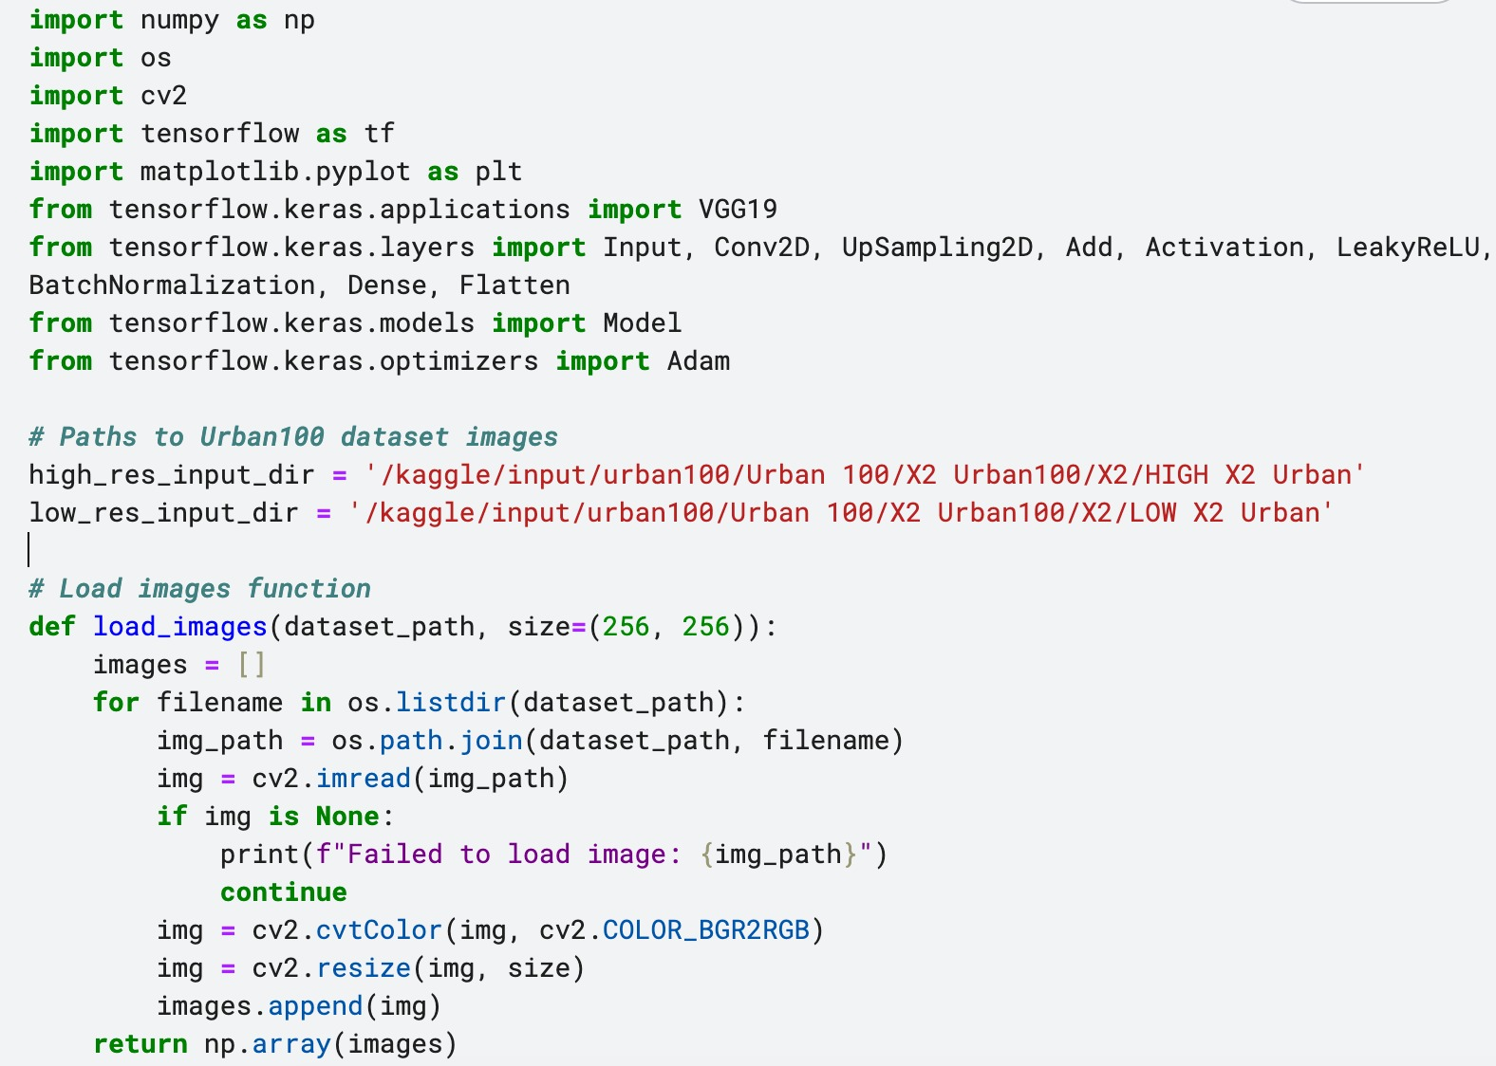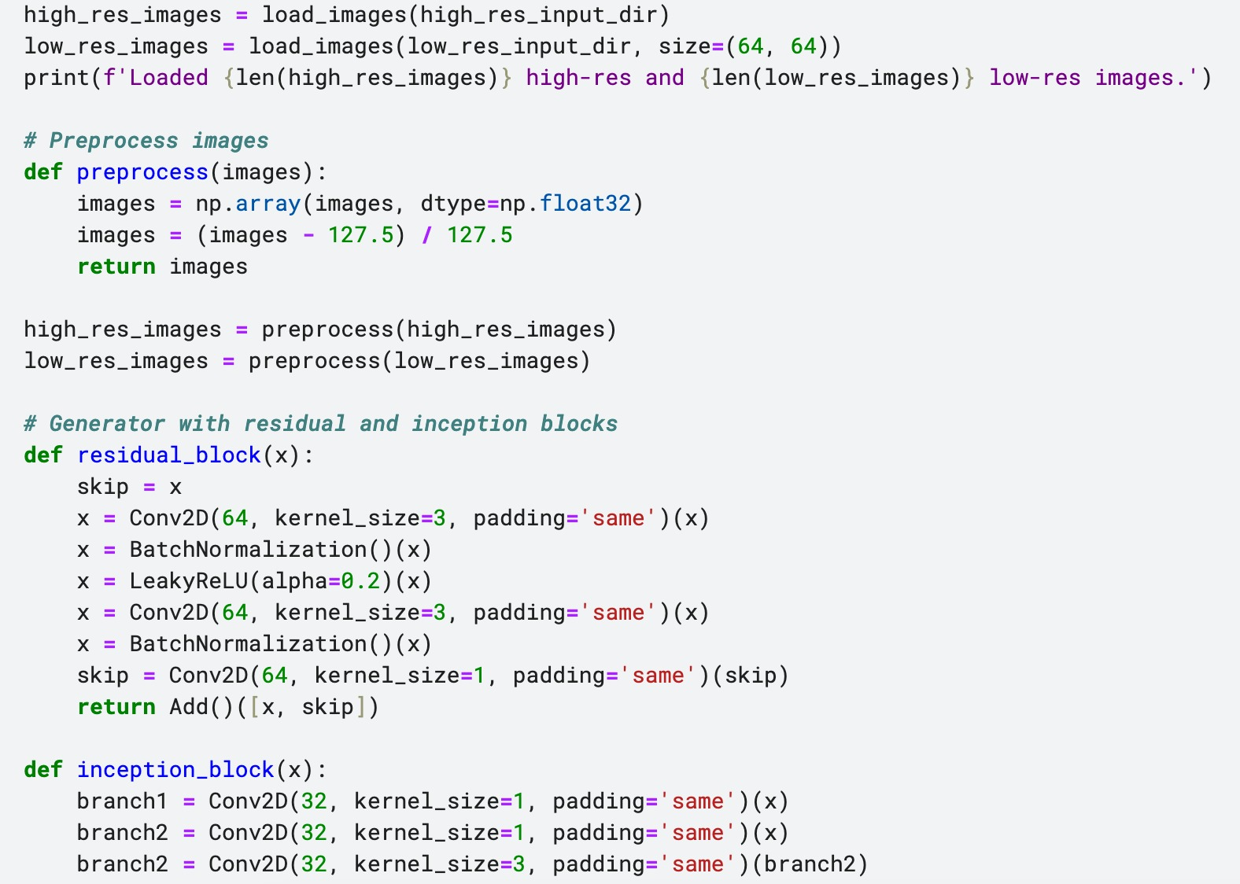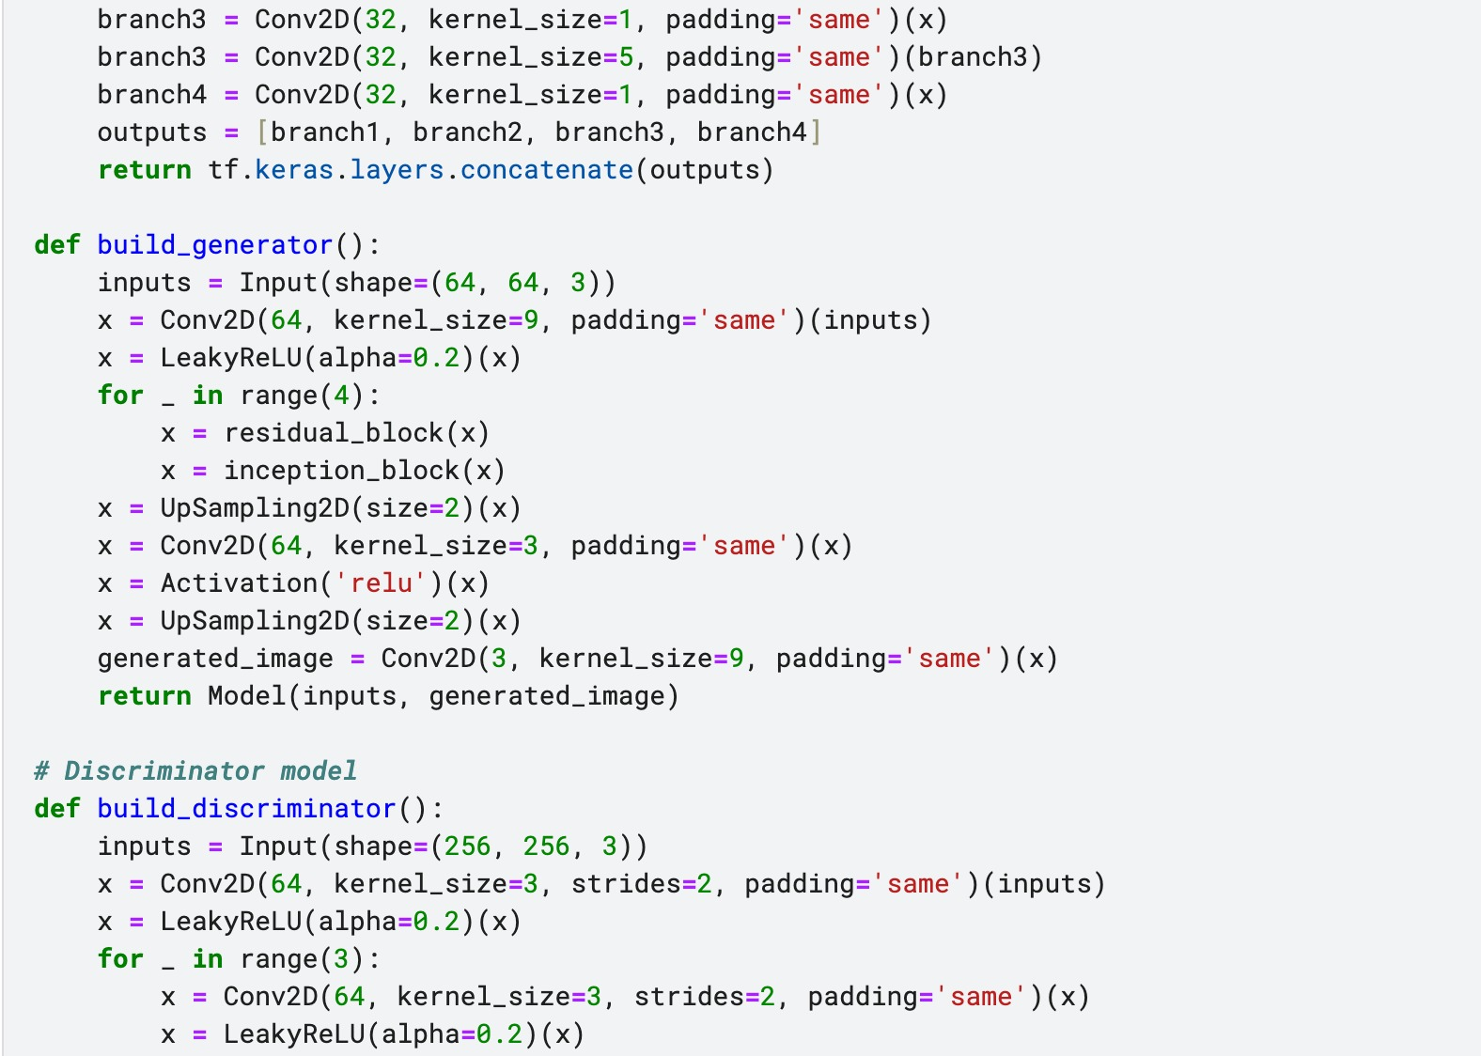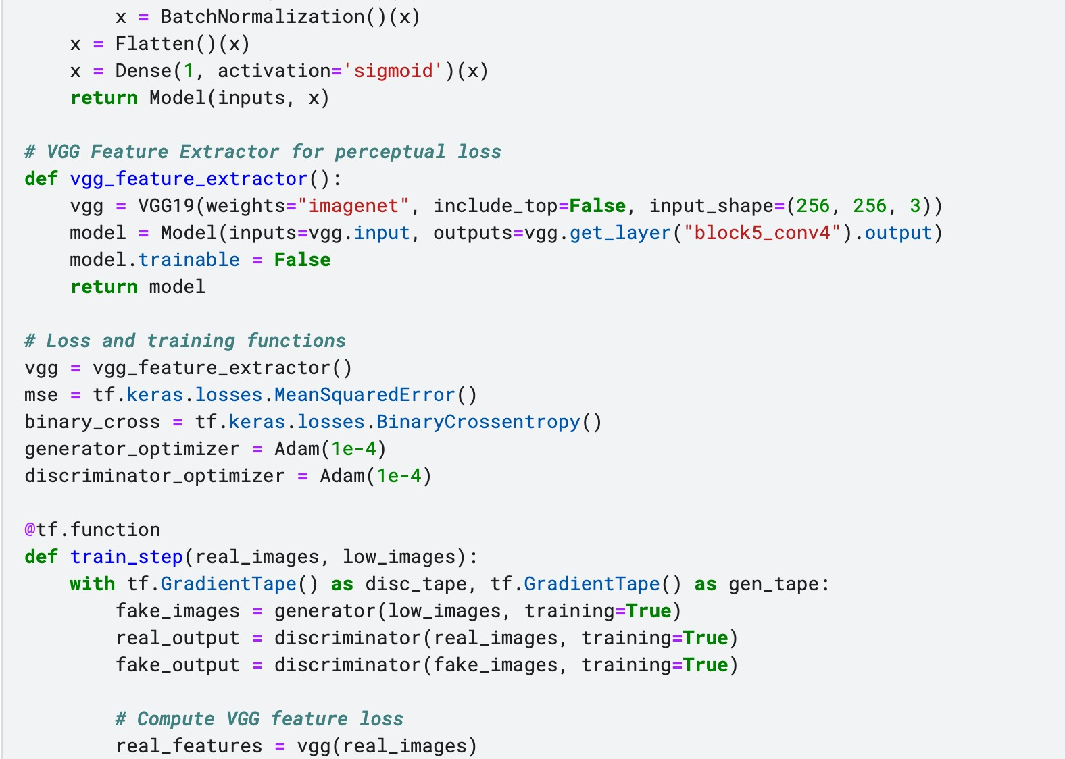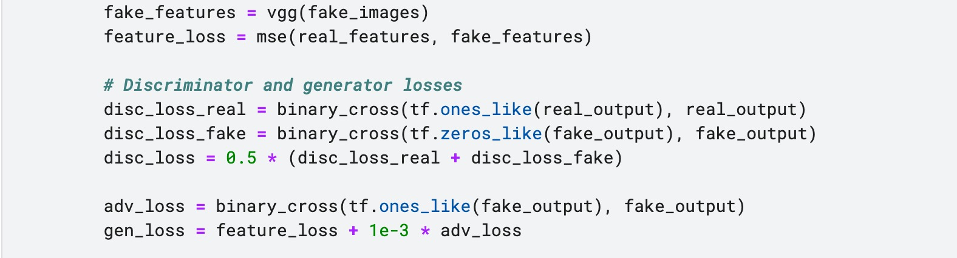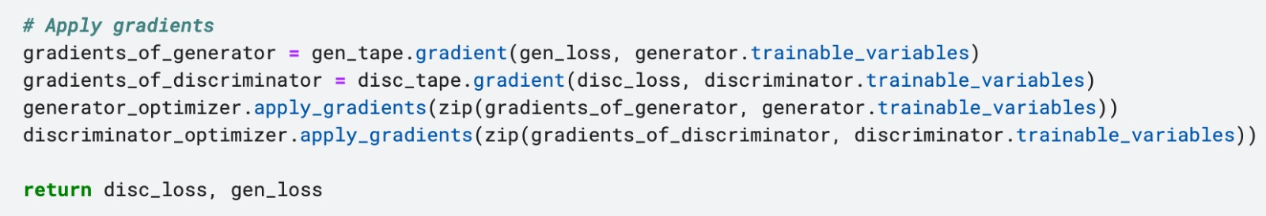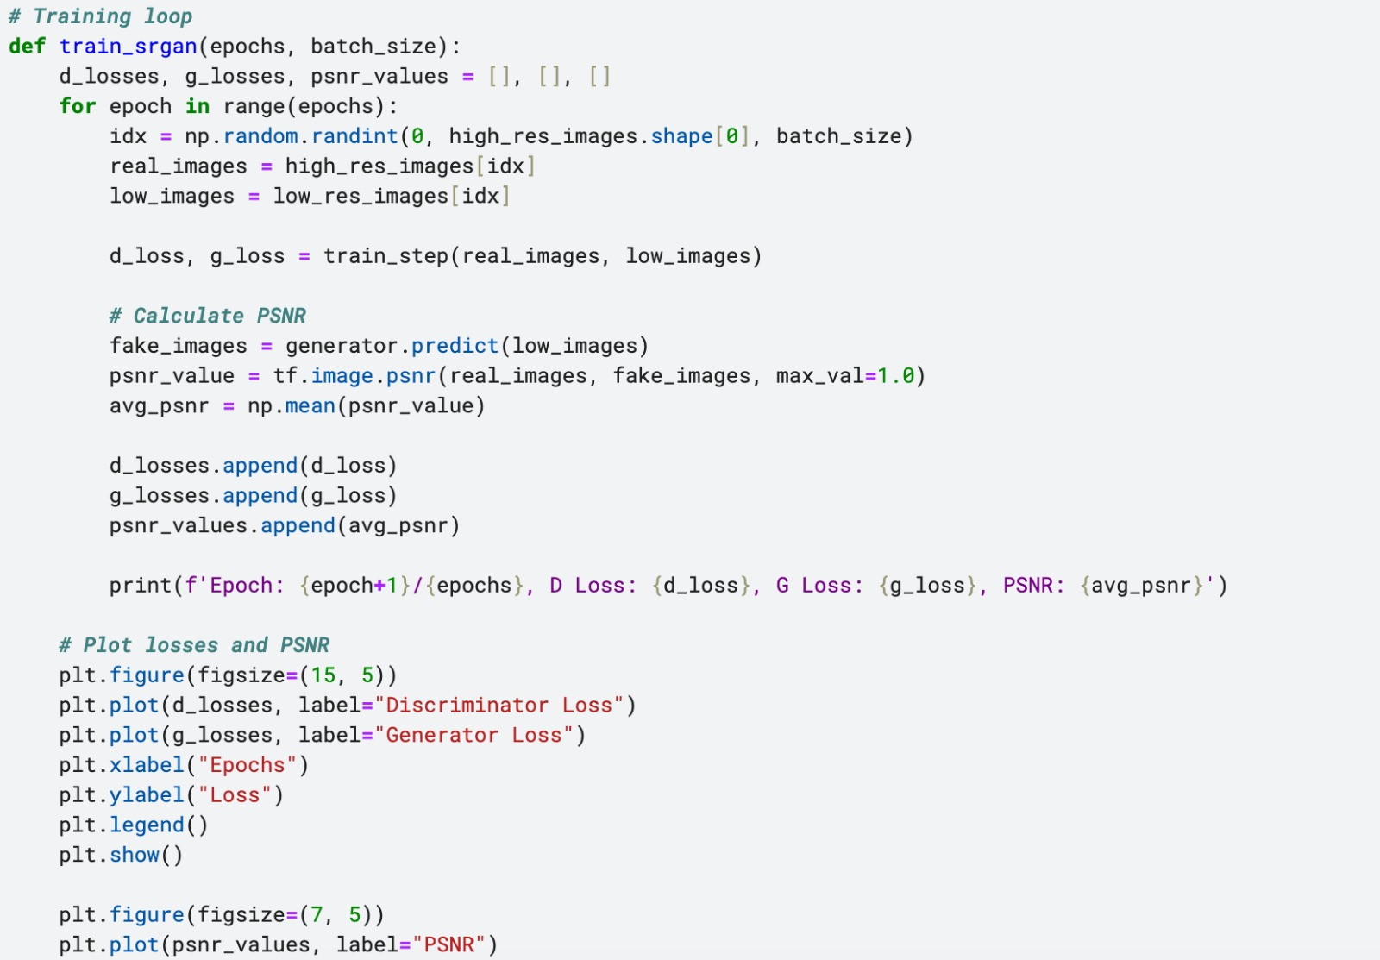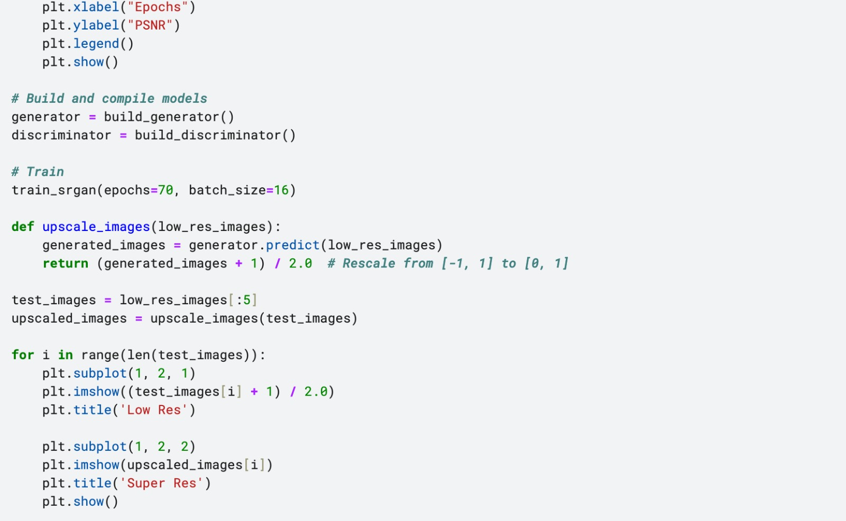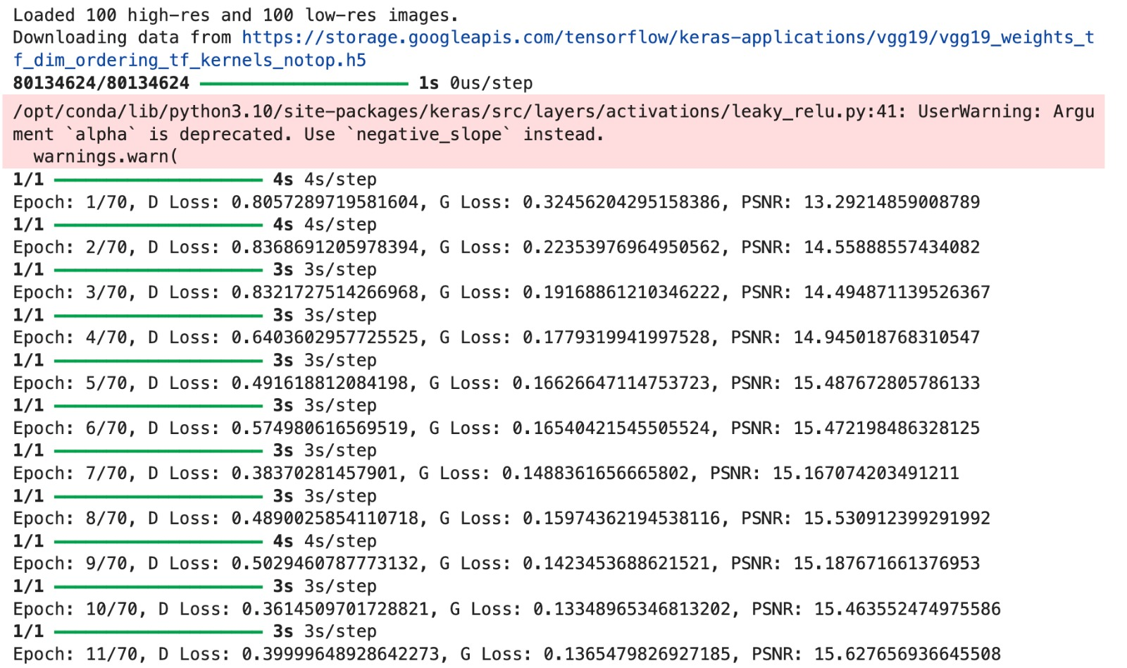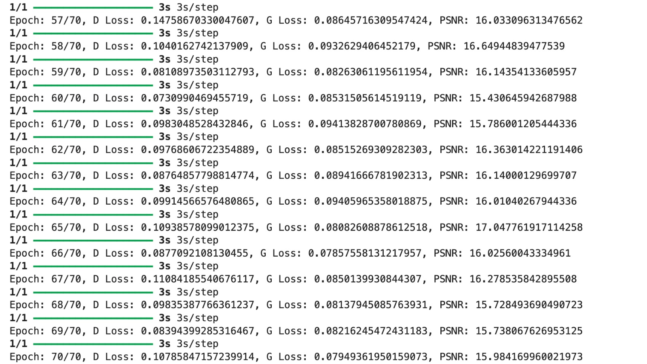

**Result**

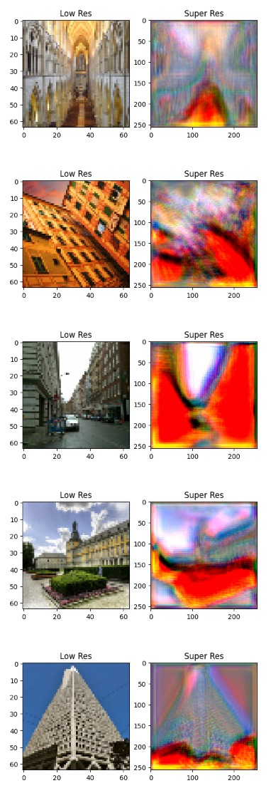

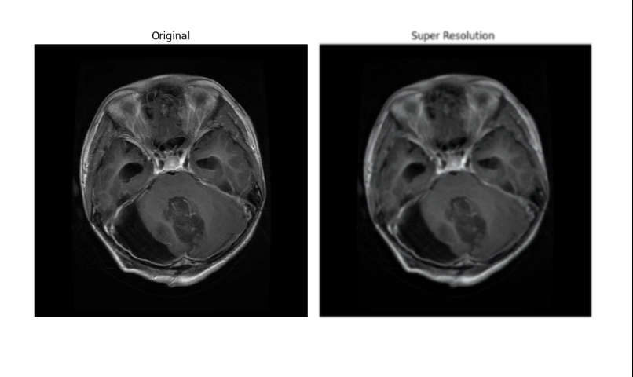

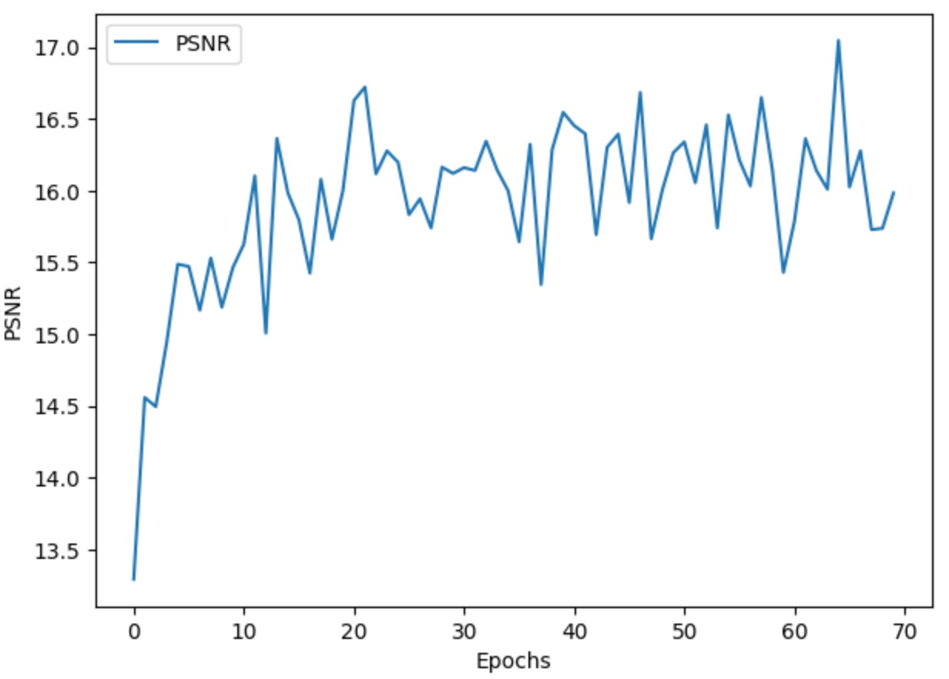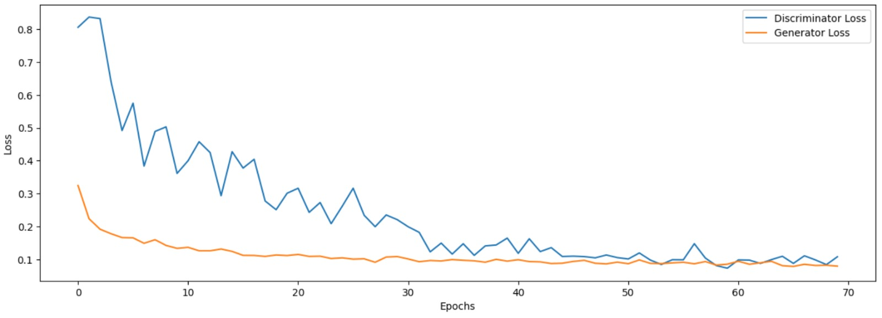

**Made By:-**

**1. Harsh 2022UCS1504**

**2. Sanket 2022UCS1507**

**3. Ayush 2022UCS1513**

**4. Yash 2022UCS1522**

**5. Lishma 2022UCS1564**

**6. Ritvik 2022UCS1567**